Resources

Consumer Content:
What’s in season this week? Fresh produce recommendations, tips, how-to and recipes can be found at www.ProduceGeek.com .

What organic produce is best this week? Shop the organic produce department like a pro – recommendations, tips, how-to and recipes at www.OrganicProduceGeek.com .

Industry Associations
United Fresh
Produce Marketing Association
Produce For Better Health 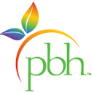
Pennsylvania Association for Sustainable Agriculture
Eastern Produce Council

Industry News
The Packer
The Produce News
Produce Business
And Now You Know

